Contents
1. Current Year Total Casualties 2
2. Current Year Total Accidents 2
3. Current Year Total Fatal Casualties 3
4. Current Year Total Serious Casualties 3
5. Current Year Total Slight Casualties 4
6. Casualties By Vechicle Type 5
7. Casualties by Monthly of the years 6
8. Casualties By Road Type 7
9. Casualties by Urban/Rural 8
10. Casualties by Day/Dark 9
11. Top 10 locations by high Casualties 10

Road Accident Analysis

1. Current Year Total Casualties
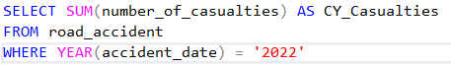
SQL Output:
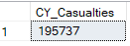

PowerBI Visualization:
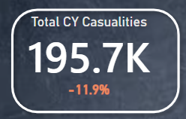

2. Current Year Total Accidents
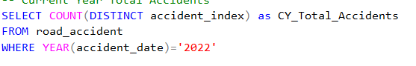
SQL Output:
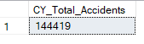

PowerBI Visualization:
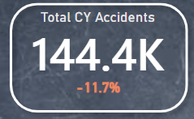

3. Current Year Total Fatal Casualties
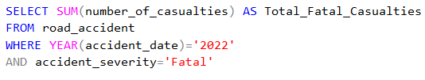
SQL Output:
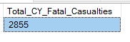

PowerBI Visualization:
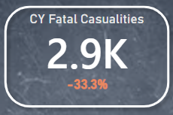

4. Current Year Total Serious Casualties
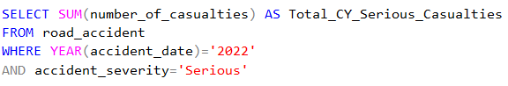
SQL Output:
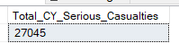

PowerBI Visualization:
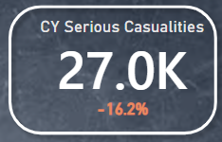

5. Current Year Total Slight Casualties
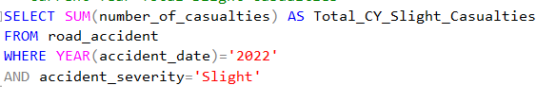
SQL Output:
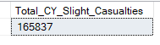

PowerBI Visualization:
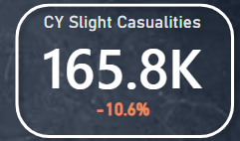

6. Casualties By Vechicle Type
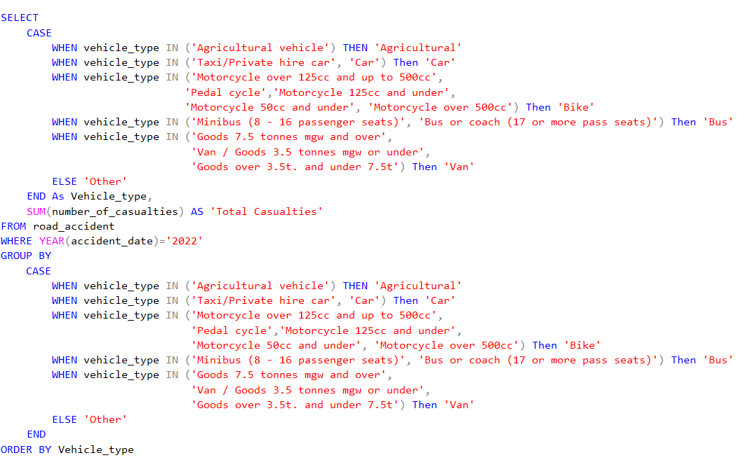
SQL Output:
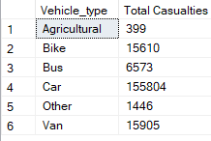

PowerBI Visualization:
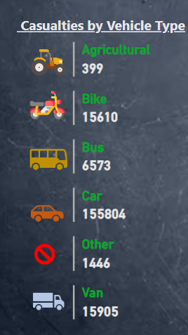

7. Casualties by Monthly of the years
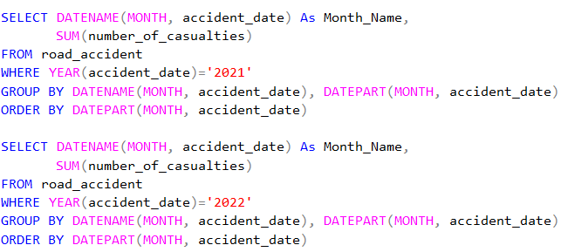
SQL Output:
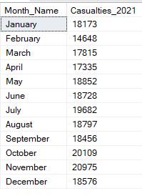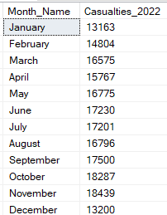

PowerBI Visualization:
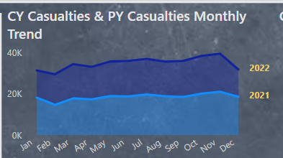

8. Casualties By Road Type
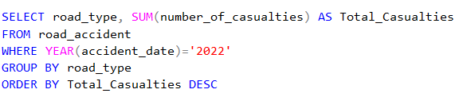
SQL Output:
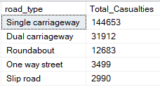

PowerBI Visualization:
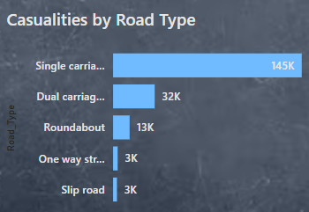

9. Casualties by Urban/Rural
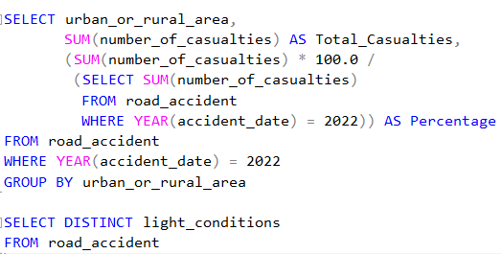
SQL Output:
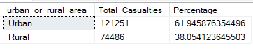

PowerBI Visualization:
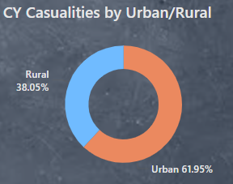

10. Casualties by Day/Dark
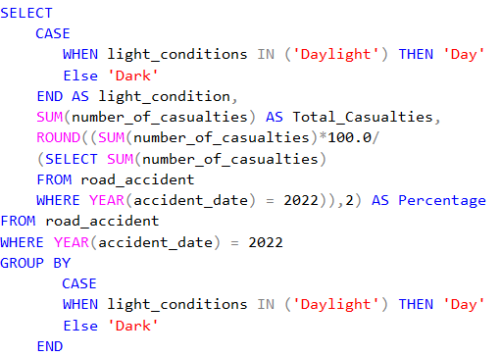

SQL Output:
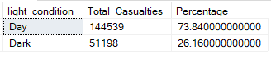
PowerBI Visualization:
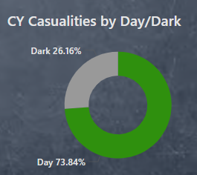

11. Top 10 locations by high Casualties
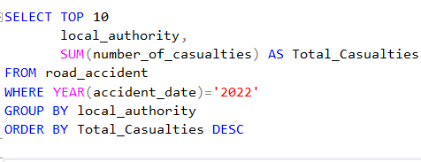
SQL Output:
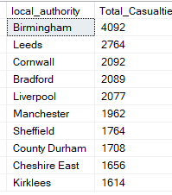

PowerBI Visualization:
